  How can I help at home?
  - Count - steps up the stairs, money into a money box etc
  - Ask children to say how many without counting (5 or fewer)
  - Play games using a dice and encourage child to say how many spots without counting
  - Ask children to set the table with enough knives, forks and plates for everyone
  - Spot numbers in the environment – on phones, microwaves, clocks, registration plates, doors.
  - Ask children to think of their own representations for numbers eg one of them, two hands, three bears, four wheels on a car, five toes, six sides on a dice, seven dwarves, eight legs on an octopus etc
  - Deliberately make mistakes. Children need to understand mistakes are normal and everyone makes them eg get mixed up when counting, muddle two numbers when ordering them
  - Watch Numberblocks on Cbeebies. This programme is written by maths specialists to model maths concepts and represents number brilliantly. Also, Numberjacks is excellent for solving problems.
  - Hide numbers around the house or garden for children to find.
  - Play outdoor maths games like hopscotch and skittles. Even better, let children make up their own games and decide how to score points
  - Read books with maths concepts eg The Very Hungry Caterpillar, One is a snail, ten is a crab, What’s the time, Mr Wolf?
  - Draw attention to more and less
  - Ask questions such as “How many more?”, “How many altogether?”, “How many would I have if…”
  A Guide to Maths Mastery in Reception
  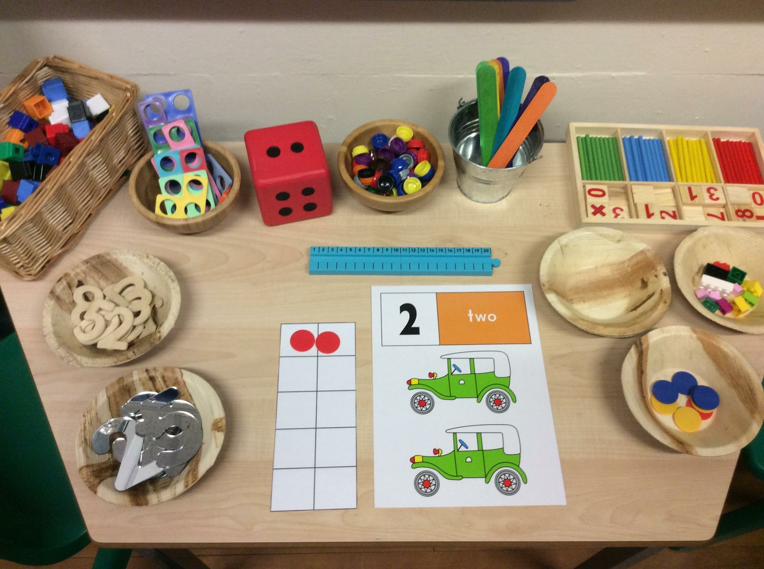
  Onslow Infant school
  

Table of Contents  What is Teaching for Mastery? 1  Early Learning Goals in Reception 2  Early Learning Goal: Number 2  Early Learning Goal: Shape Space and Measure 2  How do we teach for Mastery in Reception? 3  Fluency 4  Reasoning 5  Problem Solving 5  How can I help at home? 6 |  |  | Reasoning  Reasoning in maths helps children to be able to explain their thinking, therefore making it easier for them to understand what is happening in the maths they are doing. It helps them to think about how to solve a problem, explain how they solved it and to think about what they could do differently.  In Reception, some examples of reasoning are:  - true and false statements eg adding one to a number always makes it smaller  - spotting incorrect maths eg 1, 2, 3, 4, 6, 5, 7, 8, 9, 10  - explaining how we know something or how we worked it out  Problem Solving  Problem solving in maths allows children to use their maths skills in lots of contexts and in situations that are new to them. It allows them to seek solutions, spot patterns and think about the best way to do things rather than blindly following maths procedures.  In Reception, problem solving might include:  - spotting, following and creating patterns  - estimating amounts of objects  - predicting how many times they can do something in a minute  - sharing objects between different groups – particularly when the amount of groups change and the amount of objects stays the same  - finding different ways to split numbers eg 5 could be 5+0, 4+1, 3+2 etc
 |  |  | 5

Recognising amounts  Another skill that is very important is recognising small amounts without the need to count them. Initially this should be by using concrete objects such as those shown above but as children progress, allowing them to see groups of dots in different arrangements helps them to mentally ‘see’ how many objects are there without needing to count. This is a very important skill when children begin to add and subtract. Using dice is a good way to practise this skill before moving onto objects in different arrangements.    Understanding that the total stays the same even when the objects move  When children first start to use numbers, they often do not understand that if we move objects into another arrangement the total stays the same. We practise this with many different types of objects but a useful tool is using a tens frame to be able to move counters around.  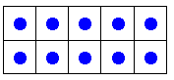  By becoming fluent in maths facts, it allows our brain to concentrate on higher level skills. |  |  | What is Teaching for Mastery?  Our Definition  Our Ethos  Teaching for Mastery
  INSERT SCHOOL  LOGO | At Onslow Infant School, we see teaching for mastery in maths as allowing the pupils to gain a deep understanding of maths, allowing them to acquire a secure and long-term understanding of maths that allows them to make continual progress to move onto more complex topics.
   | We believe that everyone can do maths and there’s no such thing as a maths person. Maths is a subject that everyone can and should be able to perform confidently and competently.
  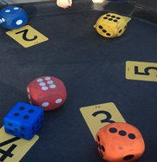 | We choose to teach by breaking down maths objectives into the smallest steps, so that every pupil is secure in every new concept before moving on. We focus upon teaching for fluency, reasoning and problem solving.
4 |  |  | 1

Early Learning Goals in Reception  There are two Early Learning Goals for Maths. This is what most children in Reception are expected to be able to do by the end of their first year at school.  Number: Children count reliably with numbers from one to 20, place them in order and say which number is one more or one less than a given number. Using quantities and objects, they add and subtract two single-digit numbers and count on or back to find the answer. They solve problems, including doubling, halving and sharing.  Shape, Space and Measure: Children use everyday language to talk about size, weight, capacity, position, distance, time and money to compare quantities and objects and to solve problems. They recognise, create and describe patterns. They explore characteristics of everyday objects and shapes and use mathematical language to describe them.  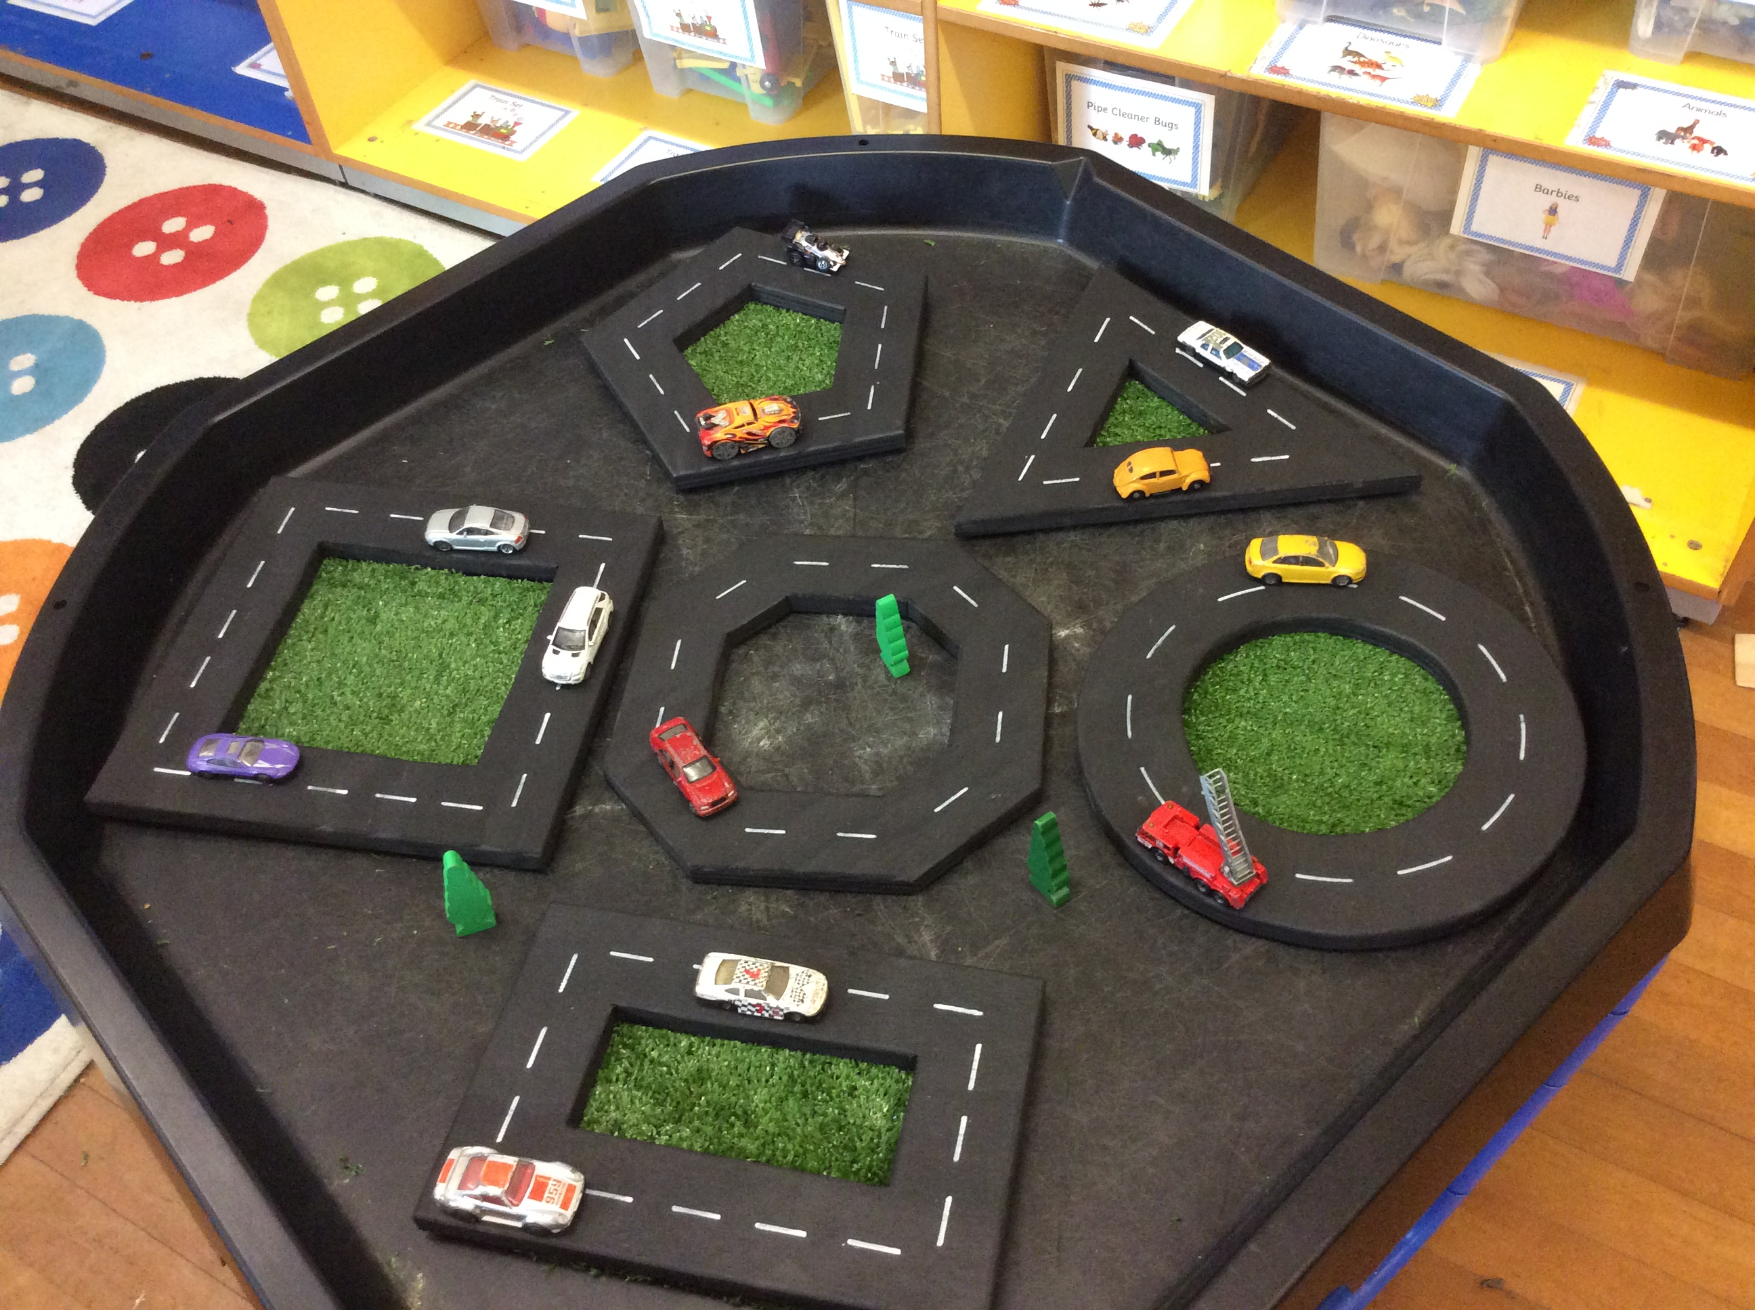 |  | How do we teach for Mastery in Reception?  Fluency  In Reception, we aim to teach so that children have a deep understanding of number.  Representing Numbers  We want to develop children’s number sense so that they understand the number rather than just recognising the numeral. Children need to understand that numbers can be represented in many ways, not just as a written numeral. We use many different objects and pictures to show that numbers can be represented in lots of ways.  Some ways to represent five  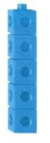  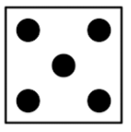 5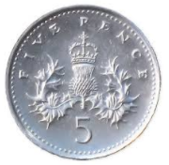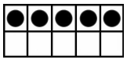  Children sometimes need lots of practise to recognise numbers in different forms. We play matching games and encourage children to recognise and make different amounts in our indoor and outdoor areas.  Counting  When counting, children need to understand that:  - That we need to say one number for each object counted (touch counting).  - The final number we say is how many altogether. Some children continue to count after they have reached the final object as they don’t connect the numbers they are saying to the objects in front of them.  - That we can count objects in any order and the total stays the same.
  3
2 3

